Project 5: Alien House

Table of Contents

Backstory to the Hut 1

Backstory to the Game 1

Where? 1

Level Design 2

Rules 4

Final Area 4

Possible Easter Eggs 6

# Backstory to the Hut

A person found an alien egg and decided to do research on it in the basement of his isolated hut. But someday the egg cracked and alien vines came out and infected the hut above them.

# Backstory to the Game

Our main character finds and abandoned looking house, and decides to walk in. When inside the character starts feeling then urge to explore and finding the explanation to the weird events occurring in the house.

# Where?

A wooden abandoned looking hut.



At night time on top of a forest hill.

* Inside the house the explorer finds a duvideous looking trap door
* Upon entering the trap door the user finds a ladder which he uses to go down.
* When down the user finds that the ladder led to the center of a square room
* That square room has four doors, one on each of its sides, and those door have different colors (Purple, Orange, Green, Blue)

# Level Design

As aforementioned, when down the ladder the user will be confronted with these colored doors, and will or not open one of them and be confronted with what’s on the other side.

These doors come in pairs, meaning that after opening one the user will have a corridor and another door of the same color its end. These corridors work as environment change allowing the user to adapt the *game feel* between the center squared room and the room on the other side of the second door.

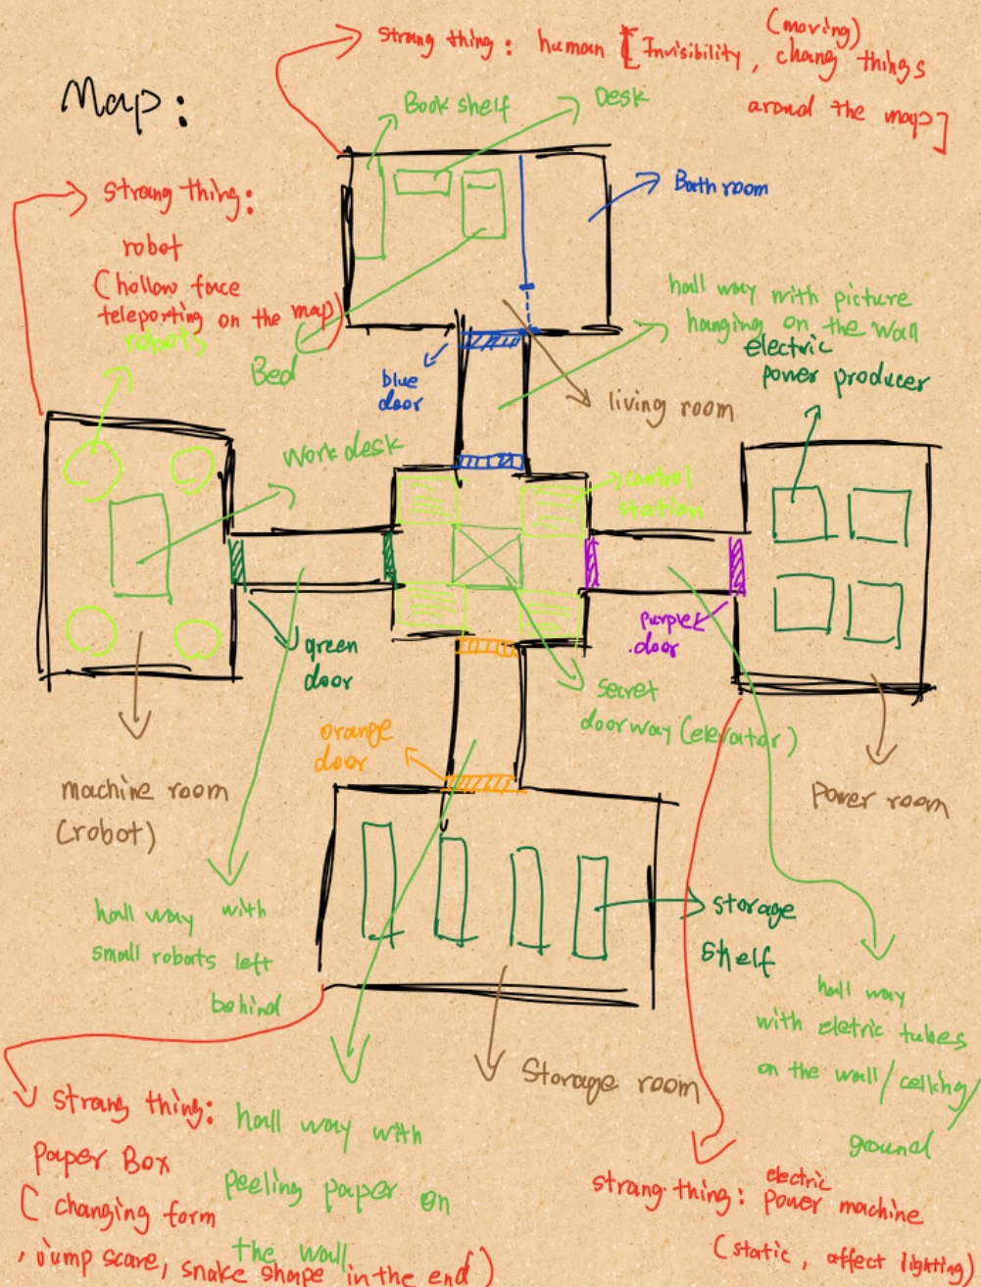

* **PURPLE:** this room is a power room, it would have 4 rectangle shaped boxes that will represent, either servers or power boxes. This room will be affected by an electrical “ghost” who will do things that will affect electric objects such as the lights and the server boxes.
  + *The corridor will have electric tubes on the walls and ground, creating an electric environment.*
* **ORANGE:** this room is thestorage room it will have 3 or 5 shelves it will be haunted by a shape shifting entity who will vary from box shape to snake.
  + *The corridor will have paper peeling off the walls and ground, creating an electric environment*
* **GREEN:** this room is themachine room, and the entity here will be of the robotic type, it will be represented by a floating head, who will haunt the player. Moving so that it stays on the field of view.
  + *The corridor will be filled with robot parts, and some steampunk type walls*
* **BLUE** this room is the living room, this room will be haunted by an invisible man, who will move objects from a place to another.
  + *This corridor will be normally decorated, with regular walls and paintings on them.*

# Rules

The player needs to solve all puzzles or fights behind each door to get a key which will allow him to activate the elevator in the center room. Each puzzle will have its own way of being solved.

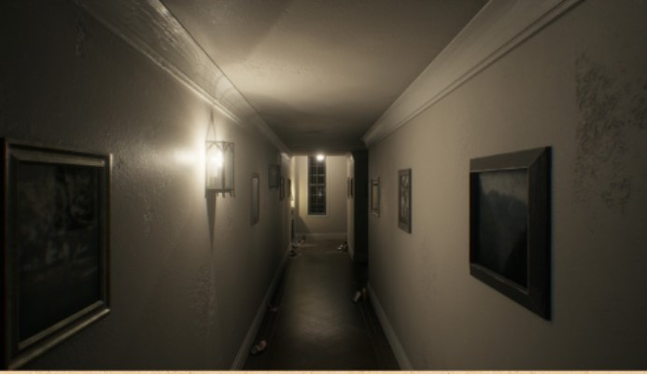Upon gathering the four keys the player will be forced to walk back to the center of the middle room, where he’ll reach the elevating platform, as the entities converge to him and the user begins to worry as to whether or not hell survive the situation, the floor in the center room will start to lower saving the user from the enemies. And getting him to the final room.

# Final Area

As the explorer reaches the bunker (final area of the map), he will find out the cause behind the strange events in the house, and (depending if we get time to develop) there will be a final boss fight, or merely an explanation.

The player will then have to switch on a lever, to destroy the egg, but before managing, the player will be intercepted, which will toggle a QuickTime event that will have to be completed in order to finish the game.

Once the alien egg is destroyed, the explorer will wake up outside the hut at dawn.

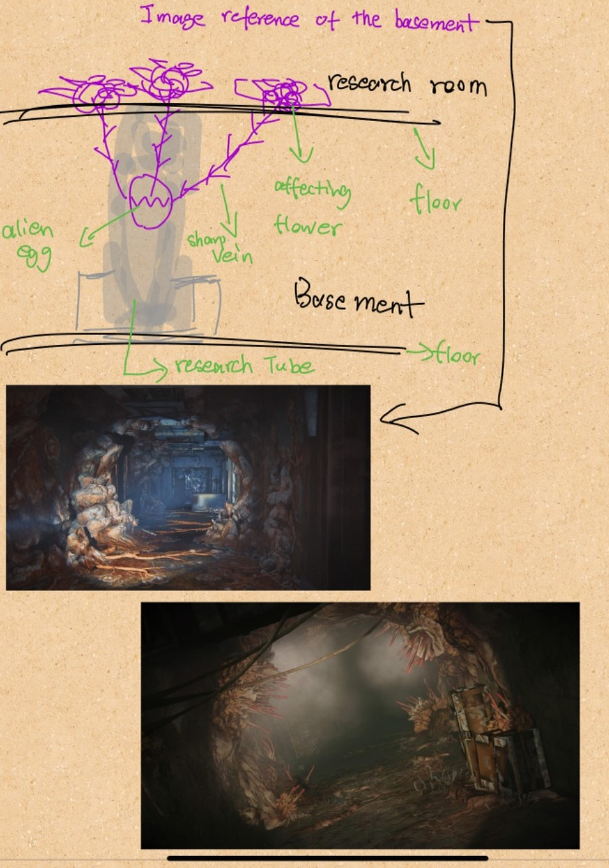

# Possible Easter Eggs

When finishing the game, a cinematic showing another egg cracking will be played, as if saying that everything is restarting, allowing multiple gameplays of the game.

During game play putting a bucket on your head will result in instant GAME OVER.

# Visual research